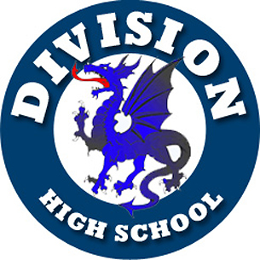
COME SUPPORT

BLUE DRAGONS VARSITY BASKETBALL
Playing at the new NASSAU COLISEUM!
Sat, Dec. 23 2017
Sponsored by the Long Island Nets
2pm: Clarke HS Rams vs. Division HS Blue Dragons
followed by
7pm: Canton Charge vs. Long Island Nets
Tickets: $16 per ticket* for both games
*Portion of ticket sales will be donated to Blue Dragons Basketball program
Parking is free initially, $5 if you leave and come back
May leave and comeback in between games until ticket scanned for Nets game
Any questions, please contact divisionhoops@gmail.com
PLEASE INCLUDE THIS PORTION WITH PAYMENT:
FIRST and LAST NAME ___________________________________________________________
EMAIL ADDRESS ________________________________________________________________
PHONE # ______________________________________________________________________
# OF TICKETS ______ AMT ENCLOSED _________ (Make check payable to Nicholas Kiphart)
Please send payment and order form to: Nicholas Kiphart, c/o Division Hoops, 43 Farm Ln, Levittown, Ny 11756

